***BE A NURSE***

**As I look around me and see how life has changed.**

**All my younger hopes and dreams have all been rearranged.**

**I used to want to be a hero fly around just doing good.**

**Learning as I got older to do the things I should.**

**I never wanted to be famous or own big fancy cars.**

**Or set foot on the moon and study all the stars.**

**I did not seek out power to tell others what to do.**

**But if I could be like anyone I'd want to be like you.**

**Helping little children and some older people too.**

**If I could go back in time I know just what I'd do.**

**I would not look for diamonds or lots of money in a purse.**

**I would be the best of heroes. I would become a nurse.**

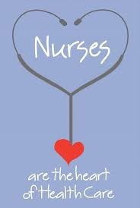

**Poem by: Edwin C. Hofert**